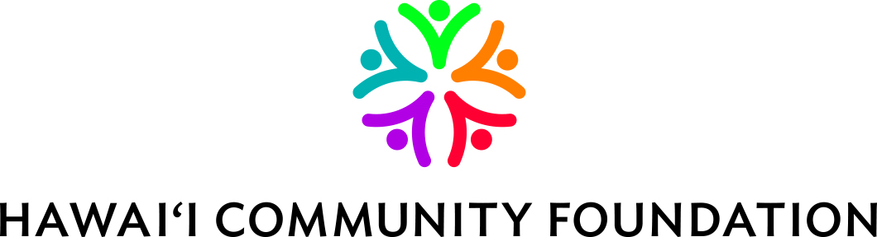

Med

Medical Research Program
Post-Grant Report
(Please submit one year after grant final report)

Date:

Grant ID number:

Organization name:

Principal Investigator name:

PI email:

Project Title:

Please check and describe where applicable:

[ ] Additional funding resulting from research funded by Hawai‘i Community Foundation
Please describe source and amount:

[ ] Publications/other dissemination of research findings resulting from research funded by Hawai‘i Community Foundation
Please describe:

[ ] Impact on PI’s professional development, or other significant outcomes resulting from research funded by Hawai‘i Community Foundation
Please describe:

[ ] There is nothing additional to report

Report should be emailed to medres@hcf-hawaii.org or mailed to:

Hawai‘i Community Foundation
Attn: Medical Research Program
827 Fort Street Mall
Honolulu, HI 96813-4317

If you have any questions, please contact Tricia Mabellos at 808-566-5523 or from the Neighbor Islands call 1-888-731-3863 or email tmabellos@hcf-hawaii.org.

